**Wednesday Coffee Club**

**Support for Job Hunters**

Hosted by

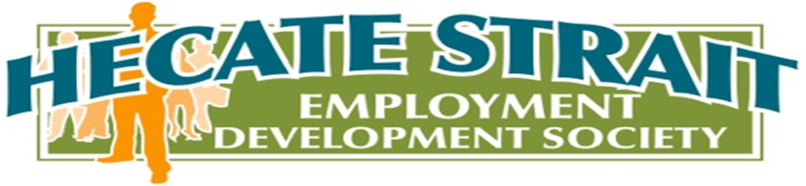

-Guest speakers

-Employment Discussions

-Participant support group

Every Wednesday @ 11am. Come have tea/coffee and snacks



Starting September 17th 2014 @ 11 am

101 Causeway Queen Charlotte (Blue Door beside Dollar Store)